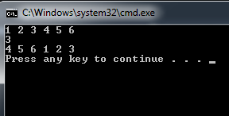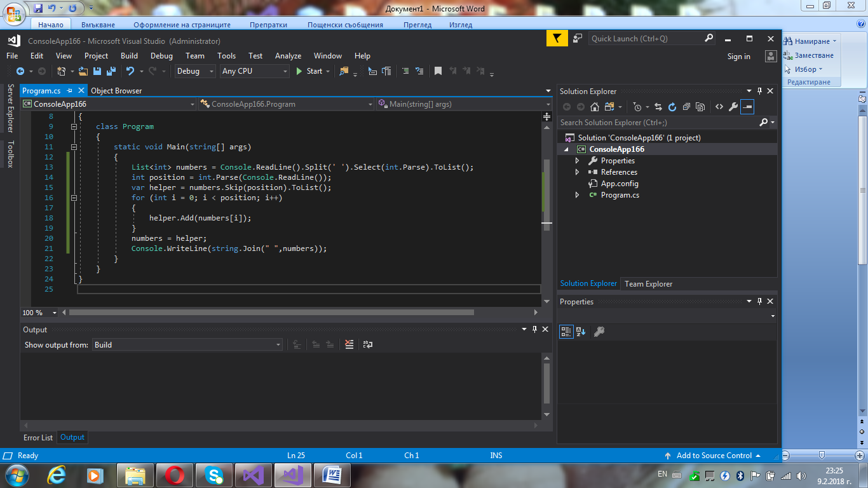

using System.Collections.Generic;

using System.Linq;

using System.Text;

using System.Threading.Tasks;

namespace ConsoleApp166

{

class Program

{

static void Main(string[] args)

{

List<int> numbers = Console.ReadLine().Split(' ').Select(int.Parse).ToList();

int position = int.Parse(Console.ReadLine());

var helper = numbers.Skip(position).ToList();

for (int i = 0; i < position; i++)

{

helper.Add(numbers[i]);

}

numbers = helper;

Console.WriteLine(string.Join(" ",numbers));

}

}

}